

Write and run the following queries:

1. Find all the records for city “CHICOPEE".

Answer:

* use assignment
* db.zipcodes.find({"city" : "CHICOPEE"})

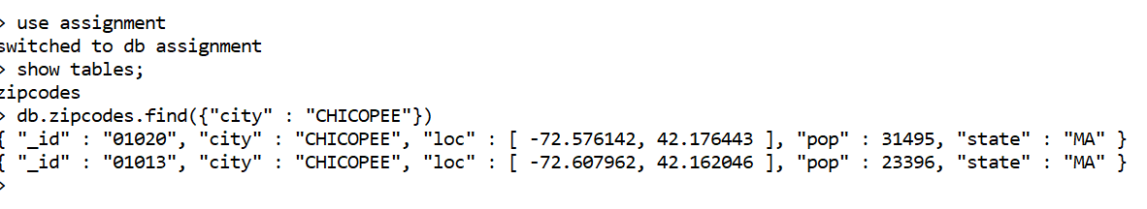

1. Display all the distinct State names which are there in this dataset.

Answer:

* db.zipcodes.distinct("state")

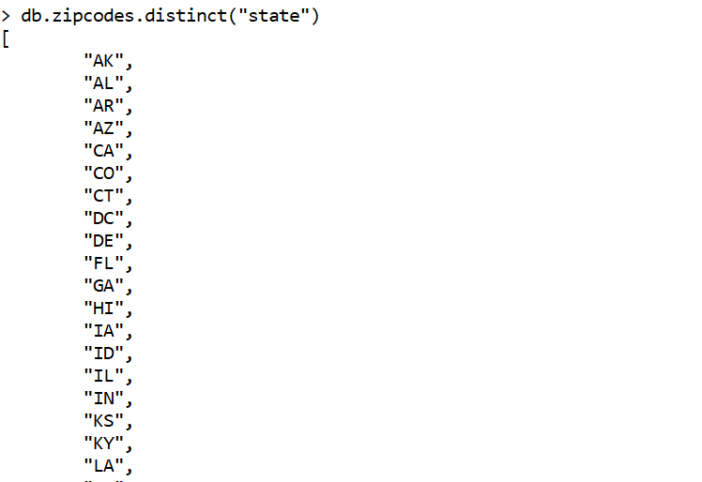

1. The records of "TOLLAND" or "MONTGOMERY" city.

* db.zipcodes.find({$or:[{"city" : "TOLLAND","city": "MONTGOMERY"}]})

1. The list of cities name for the state “VA”

db.zipcodes.distinct("city",{"state": "VA"})

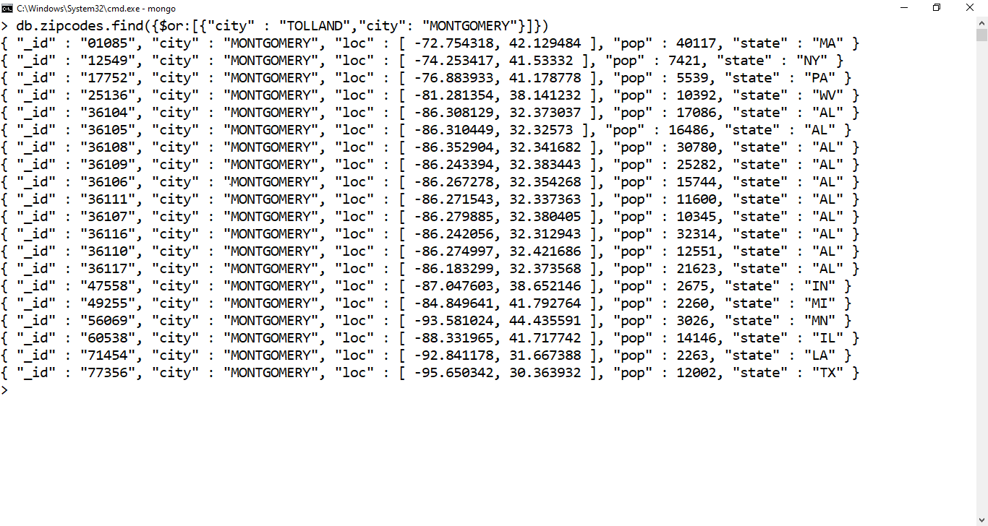

1. The name of cities where "population” is greater than 33801.

db.zipcodes.find({"pop": {$gte:33801}},{"city":1,_id:0})

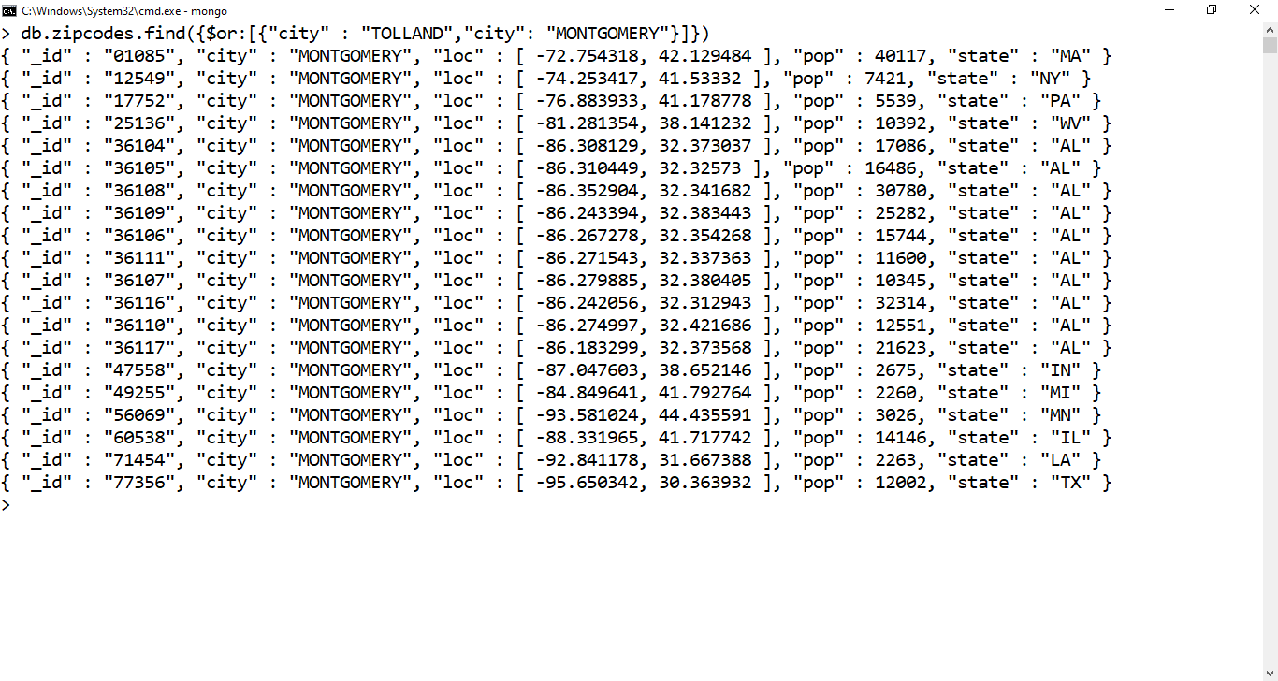

1. The names of the state and its total population whose poulaiton is greater than 5000000

db.zipcodes.aggregate([ {$group: {_id: "$state",totalPop: {$sum: "$pop"}}}, {$match: {totalPop: {$gte: 5000000}}} ])

